**Age Segmentation of Respondent**

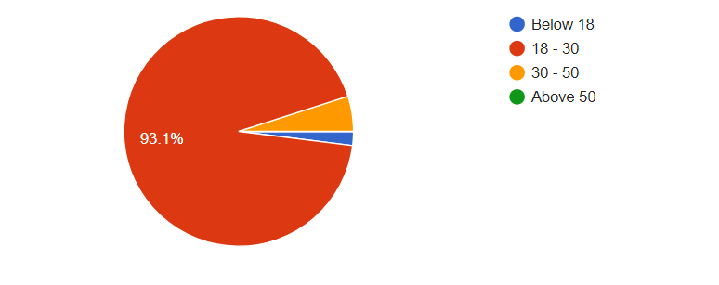According to the survey results, ninety-four respondents representing 93.1% of total respondent belongs to the age between 18 to 30 years, five respondents representing 5% pf respondent belongs to the age between 30 to 50, while only two respondents representing 1.9% of total respondent belongs to age below 18 years and none of the respondent is above the age of 50.

**Gender of respondents**

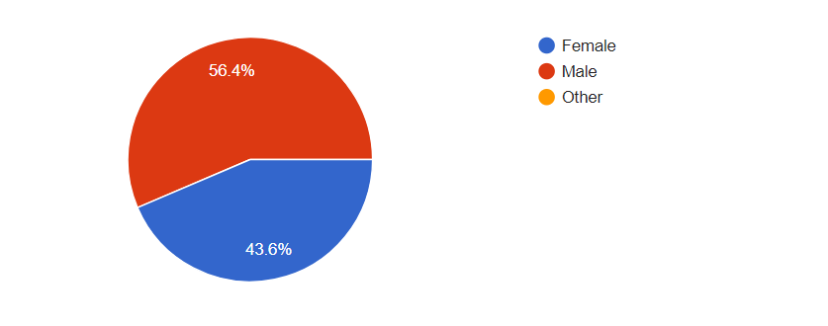Results shows that majority of the respondents representing 56.4% of total respondents are male, while remaining rest are females and none of the respondents belongs to other group.

**Type of user**

**A close up of a logo

Description generated with high confidence**As per the survey results all of the respondent belongs to tenant (International student), while only one respondent is Agent and none of the respondents is Landlord.

**City of residence of tenants**

**A screenshot of a cell phone

Description generated with very high confidence**As per the survey results seventy-three respondents representing 70.3% of total respondents belongs to Dublin, while eight respondents representing 7.9% of total respondents belongs to bray and other belongs to different cities of Ireland.

**How long have you been living in Ireland?**

**A close up of a logo

Description generated with high confidence**

As per survey results sixty respondents representing 62.4% of total respondents are living in Ireland for 6 to 12 months, fifteen respondents representing 14.9% of total respondents are living in Ireland for 0 to 6 months and very few of them are living for more than an year.

**Smartphone OS Type?**

**A screenshot of a cell phone

Description generated with very high confidence**When asked about the operating system from the respondent, majority of them representing 77.2% of total were using android, while 30.7% of respondents were using apple and very few them were using other operating systems.

 Have you ever faced any issue with your Landlord and Agent during tenancy period?

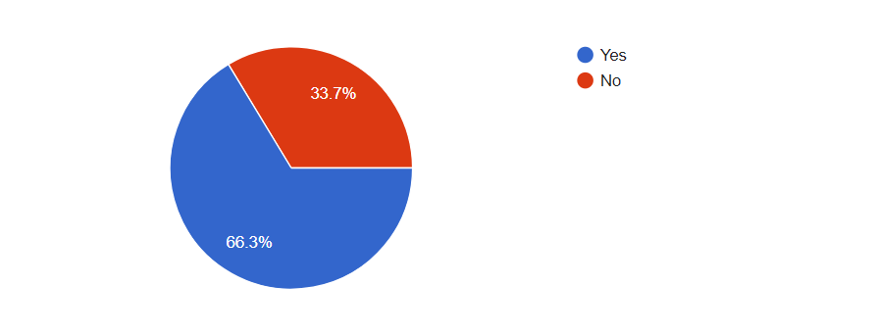

When asked about the problems did they ever face, majority of the respondents representing 66.3% of total respondents said “YES”, while other said “NO”.

Who manages your house during your tenancy period?

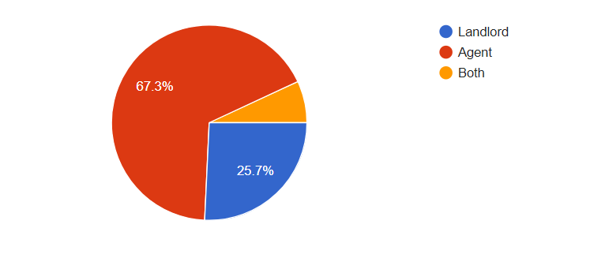As per survey results most of the rented properties (67.3%) are managed by Agents, 25.7% of properties are managed by landlords and very few properties are managed by both.

 If your rented house needs any maintenance work done then, how many days does it take for an agent to get it fixed?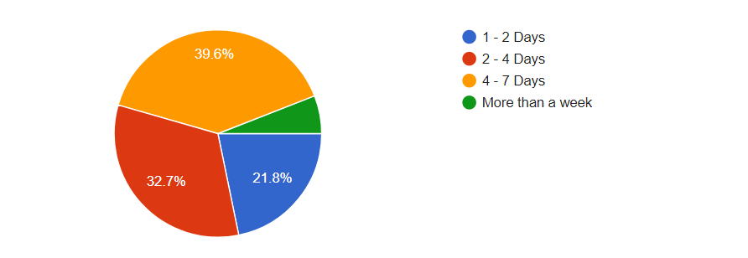According to survey results, forty respondents representing 39.6% of total respondents said that it takes 4 to 7 days to get work done, while thirty-three respondents representing 32.7% of total respondents said that it takes 2 to 4 to get work done, twenty-two respondents representing 21.8% of total respondents said that it takes 1 to 2 days to get work done and very few said it takes more than one week.

 Assume that you are in a situation where you have an issue with your agent and landlord which is unable to resolve mutually, then what would be your next step?

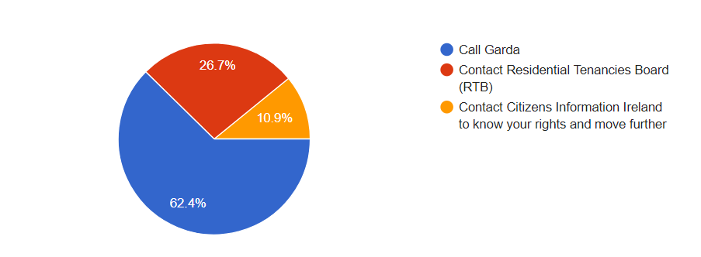when asked from the tenants about the next step they would take when they have a issue with landlord or agent, 63 tenants representing 100 tenants said they would like to call garda, 27 tenants representing 100 tenants said they would like RTB and some said they would like to contact citizen information Ireland to know their rights.

As a tenant, do you feel that there is any communication gap with your agent and landlord?

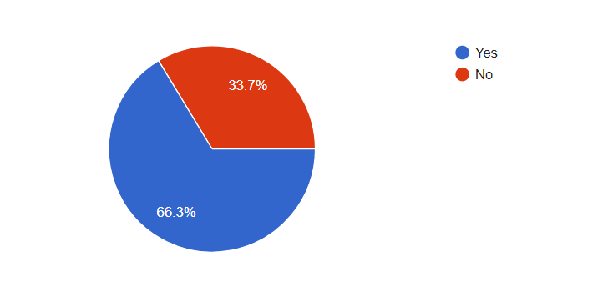 According to survey results, sixty-seven respondents representing 66.3% of total respondents said “YES#” and thirty-four respondents representing 33.7% of respondents said “NO”.

Did you ever come across any tenant, agent and landlord Messaging APP?

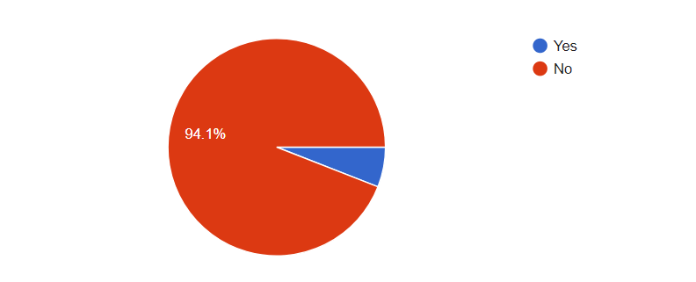As per survey result, ninety-five respondents representing 94.1% of total respondents said “NO”, while some of them said yes.

What if an APP is designed and implemented where only tenants, agent and landlord can use the chat feature to discuss any problems and seek permission from the landlord for repair or maintenance etc. and to rate and post feedback on each others profile and have all Disputes and Rights related details in the APP itself. Will it be helpful?

A close up of a logo

Description generated with high confidenceAs per survey results majority of the respondents said “YES”, while some said “Maybe” and very few said “NO”.

Do you think using this APP will reduce the communication gap between tenants, agent and landlord?

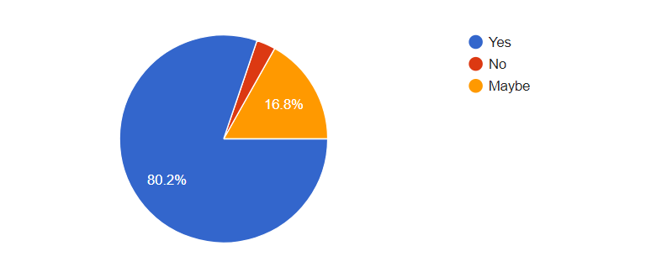

As per survey results, eighty-one respondents representing 80.2% of the respondents said “YES”, seventeen respondents representing 16.8% of the said “Maybe”, while very few said “NO”.

Do you think the rating and posting feedback feature on each others profile(tenant, landlord and agent) will eliminate the need of Reference Letter for a tenant searching a new house?

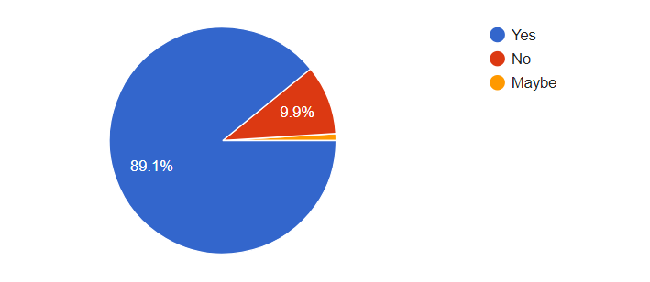

As per the survey results ninety respondents representing 89.1% of total respondents said “YES”, ten respondents representing 9.9% of total respondent said “NO” and very few said “Maybe”.

How helpful will this APP be in future on a scale of 5?

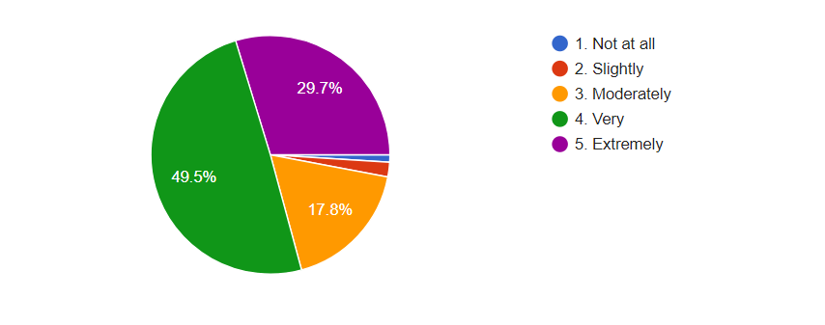

Fifty respondents representing 49.5% of total respondents said “very helpful”, thirty respondents representing 29.7% of total respondents said “extremely”, eighteen respondent representing 17.8% of total respondents said “Moderately” and very of them said “slightly” and “not at all”.